Mr./Ms/Mrs. _________________
Grade ______
Parent Information Package
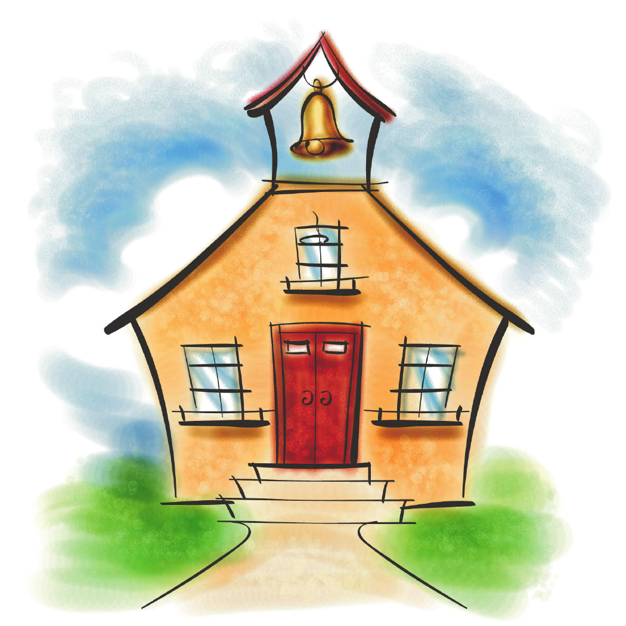

Name________________________
Email:
Website:

WELCOME BACK!!!
Useful Information

Student Planners
Every year, students at ____________ Elementary are provided with a planner. Our class will be using the planner to record daily reminders regarding homework, notices, upcoming events, etc. We will be checking the planners every morning. If you ever need to write me a quick note, please feel free to use the communication box to do so, or send a note in the pouch at the front of the planner.

Gym Days
Our gym times have been scheduled for ______________________. Please send a pair of indoor running shoes that your child can wear in class and use in the gym. Students will need a t-shirt and shorts (or appropriate gym attire); having gym strip is part of your child's participation mark.

Library Days
Our library exchange block will be on ______________. We will use these books to read in class, as well for home reading.

Snacks
We will have a snack break every morning. In order to encourage healthy eating habits and ensure students are able to concentrate and learn to the best of their ability, they will only be allowed to eat healthy snacks in the morning and no juice until lunch. Veggies, fruit, yogurt, cheese, healthy crackers, muffins, or granola/cereal bars, etc. will all be allowed. Thank you for your cooperation in this manner.
* Students can keep water bottles on their desks at all times.
* We have some students with severe allergies in the school, so no nuts or nut products of any kind are allowed in our classroom. Please and thank-you!

Homework
In my class, it is expected that students read each day for 20-30 minutes every night. This will help to improve the reading ability of all students in this class. They may choose their own books. Students do not need to keep a reading log, but will be kept accountable by recording what they are reading at school.

*Please note that I only send work home if the student needs extra time to work on an assignment.

Spelling
We will be using the Words Their Way program. Students will be given a list of words that they are to study for their tests on the following Friday. Students will have the same words for 2 weeks to ensure that the “rule” is learned. Tests will not happen consistently, but you will be informed in your child’s planner when a test is approaching.

* In no way should daily reading or studying be reducing you or your child to tears! Please email me if this is happening so we can look at making some changes.
Behaviour Expectations

We will be creating rules as a class, but these are the behaviours expected of students in _____ grade…

1. Listen attentively and participate in discussions.
2. Raise your hand, unless requested to call out answers and ideas.
3. Be polite.
~ say please, thank-you, excuse me
~ use a respectful tone of voice
4. Be kind.
~ say & do nice things for others
~ include others
~ compromise, cooperate, collaborate
5. Move and talk appropriately in the classroom.
~ no running or yelling across the room
6. Walk silently in the halls and be a good example for younger students.

Rewards
Class Marble Jar:
Students will have a variety of opportunities each week to earn reward marbles as a class. When they have earned 15+ marbles we will have a class party! At these parties, the first half of the day is spent doing a class activity, and the other half is spent doing an activity that the class chooses.

Consequences:
Students will be given reminders or warnings to try to help them correct their behaviour before a consequence is given. Each child will be given 3 warnings. If the child does not improve his/her behaviour, he or she will be given a consequence. If the behaviour continues, the student will be sent to the office to speak to the principal, a note will be sent home to be signed by a parent, and a consequence will be given at school. Any type of aggressive behaviour will be dealt with immediately.

Typical consequences in my classroom include:
• time-out (moved to a quiet area of the classroom, or hallway if necessary)
• privileges removed
• time at the office (apology note)

Inside the Classroom

Lockers:
Indoor shoes can be left on the shelf in the locker end of the day. I recommend bringing a bag to store gym strip.
Jobs:
Students will be assigned jobs in the classroom in order to maintain a clean and friendly classroom. They will be responsible for this job for one week and then we will rotate so that every child has an opportunity to complete each job.

VIP:
Each week, we will have a new VIP. The VIP will be celebrated that week and will share 3 items with the class that represent him/her, so that we get to know each other better. The VIP will also lead our weekly class meeting at the end of the week.
Additional Information

In order to create a classroom where students can learn, I want to create a level of comfort. Students are invited to bring a pillow or cushion that they can use during our reading block. This pillow will need to be able to fit in your child’s locker. If it does not fit, it will be sent home. No beanbags please!

We use whiteboards in our classroom. If you could send a stray sock/mitten/cloth to be used as an eraser, that would be wonderful!

I have a website and I PROMISE that I will TRY to update it to the best of my ability! I have posted how grades are earned, and how I use Evidence of Student Learning to assign grades.

Please see attached year plan and schedule.

Learning Celebrations

Thank you for your help and support!

NAME

