Name
Address
Phone
Email

Parent Engagement Fact Sheet
Date:

Research
The current research overwhelmingly shows that parent engagement in their child’s education has many positive effects. The goal of this fact sheet is to inform you, the parents/guardians, of the positive benefits of being an active member in your child’s education.

Goals
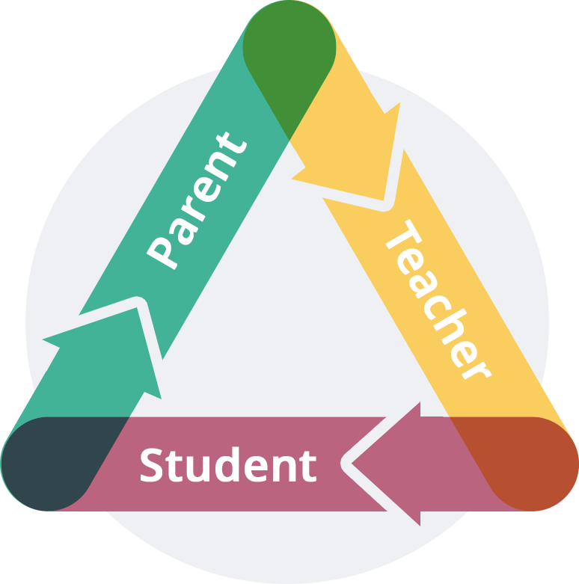
Every family has different needs, dynamics, time restraints, schedules, cultural backgrounds, and situations that make all families unique. Like families, classrooms are unique communities that function together to reach a common goal of student success. Similarly, one of the reasons we strive to create positive relationships between parents and teachers is to promote student success and achievement through a team approach. A parent or guardian who acts as a child’s co-pilot through their education offers their child a better chance of being successful emotionally, socially and academically.

Facts
- Parent involvement is an essential part of a child’s development and especially impactful on their academic success.
- Parent involvement has been strongly associated with improvements in cognitive, language, and social emotional development. It also can positively impact self-esteem, social inclusion, emotional regulation and self-perception of academic competence.
- Parent expectations and aspirations for their child have a very strong correlation with student achievement compared to other forms of parental behavioural involvement.
- A parent’s own beliefs, attitudes, and values towards education strongly correlate with their own child’s beliefs, attitudes and values towards education.
- The strongest associations between parent involvement and student success can be achieved in the following ways:
  - reading at home,
  - holding high expectations/aspirations for a child's academic achievement and schooling,
  - communicating with a child about school, and
  - encouraging and supporting the child in terms of learning outcomes.
- Higher communication between households and schools promotes increased parent awareness about student progress and creates shared goals that encourage an environment for higher achievement and role-modeling of appropriate behaviour.
- Increased communication can positively impact the student’s self-work efficacy, school engagement and intrinsic motivation towards school.
References
- Epstein, 1992; Hill & Taylor, 2004; Jeynes, 2016; Wilder, 2014; Wong et al., 2018
- Oswald et al., 2018; M.-T. Wang & Sheikh‐Khalil, 2014; Niia et al., 2015; USDHHS, 2016
- Boonk et al., 2018; Wilder, 2014
- Castro et al., 2015; Wilder, 2014
- Boonk et al. (2018)
- Hill & Taylor, 2004; Stevens & Patel, n.d.
- Fan & Williams, 2010; Goodall & Montgomery, 2014
This work by Sean Gorman is licensed under a Creative Commons Attribution 4.0 International License.

